Introductory Economics for Business and Finance (IC103)
Tutorial 3
Answer the following questions and come to class ready to explain how you got those answers.
1. In indifference curve analysis, the consumer will maximise utility at the point where:
a) The budget line intersects the indifference curve
b) The budget line is tangential to the indifference curve
c) The budget line is above the indifference curve
d) The budget line is below the indifference curve
2. When the price of a good changes, a consumer will respond by changing the quantity demanded. The part of the change that is called the substitution effect represents the consumer’s response to:
a) The change in the consumer’s nominal income
b) The change in the consumer’s real income
c) The change in relative prices
d) An induced change in the consumer’s preferences
3. Assume that the price of X is £20 and the price of Y is £40.
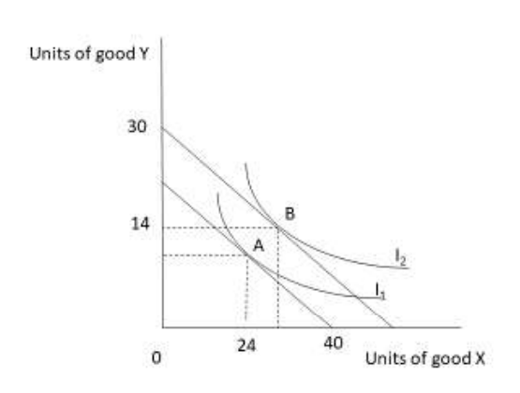
If indifference curve I₂ represents the highest level of utility the consumer can achieve, what is their income?
a) £480
b) £600
c) £800
d) £1200
4. Referring to the diagram in question (3), if the consumer locates at point B, how many units of X will they consume?
a) 28
b) 30
c) 32
d) 60
5. When deciding between an expensive, high-quality product and a cheaper, lower-quality product, which of the following offers the best value for money?
(a) The product with the lowest price
(b) The product with the highest quality
(c) The product that provides the highest total utility
(d) The product that provides the highest utility per pound spent
6. Steve spends his income of £120 on only concerts and cinema tickets. The concerts cost £15 per ticket and the cinema costs £10 per ticket.
a) Calculate and plot his budget constraint.
b) What happens if his income increases to £150?
c) What happens if his income stays at £120 but cinema tickets fall in price to £5?
7. Max employs labour and capital to produce widgets. Currently, the last unit of labour employed has a marginal product of 100 units. The last unit of capital employed has a marginal product of 40 units. The price of labour is £25 per unit and the price of capital is £10 per unit. Max should:
- Use more of both factors of production
- Hire more labour and use less capital
- Hire less labour and more capital
- Keep the current combination of labour and capital, as both factors provide the same marginal product per pound spent
8. If a firm is producing at a point where diminishing marginal returns have set in, which of these statement(s) is/are true?
(i) Each additional unit of output will be more expensive to produce
(ii) Each additional unit of output will require increasing amounts of the variable factor of production
(iii) The marginal product of the variable factor of production decreases as the quantity used increases
a) (i) only
b) (i) and (ii)
c) (ii) and (iii)
d) All are true

Optional question: Can you think of a real-life example of the law of diminishing marginal returns?

